GITAM UNIVERSITY
BENGALURU CAMPUS
DEPARTMENT OF COMPUTER SCIENCE AND ENGINEERING
ARTIFICIAL NEURAL NETWORKS (ANN)
PROJECT REPORT
Student Performance Prediction Using
Multiclass Multilayer Perceptron (MLP)
Submitted in partial fulfillment of the requirements for the course
ARTIFICIAL NEURAL NETWORKS
Submitted by
[C.Nidheesh Reddy]
[2023003665]
Under the Guidance of
[Dr.Anantha Babu S]
ACADEMIC YEAR 2026-2027

DECLARATION
I hereby declare that the project report entitled "Student Performance Prediction Using Multiclass Multilayer Perceptron (MLP)" is an original record of work carried out by me under the guidance of [Dr.Anantha Babu S], Department of Computer Science and Engineering, GITAM University, Bengaluru Campus. I further declare that all data, results, graphs, and metrics presented in this report are derived from the actual implementation of the project and are not fabricated, plagiarised, or borrowed from any other source without proper acknowledgement.
This project report has not been submitted to any other university or institution for the award of any degree or diploma.

Student Name: C.Nidheesh Reddy
USN / Roll No.: 2023003665
Signature: Nidheesh Reddy
Date: 16/10/2026

CERTIFICATE
This is to certify that the project report entitled "Student Performance Prediction Using Multiclass Multilayer Perceptron (MLP)" has been prepared by [C.Nidheesh Reddy] bearing USN [2023003665] under my supervision and guidance, in partial fulfillment of the requirements for the course Artificial Neural Networks (ANN) at GITAM University, Bengaluru Campus, during the Academic Year 2026-2027.
The work presented in this report is genuine and satisfactory, and this report has not been submitted to any other university or institution for the award of any degree or diploma.

Faculty Guide: Dr. Anantha Babu S
Designation: Assistant Professor
Signature: ____________________________________
Date: 16/10/2026

ACKNOWLEDGEMENT
I would like to express my sincere gratitude to [Dr.Anantha Babu S], Department of Computer Science and Engineering, GITAM University, Bengaluru Campus, for providing invaluable guidance, continuous support, and constructive feedback throughout the course of this project. Their expertise in Artificial Neural Networks has greatly contributed to the successful completion of this work.
I am also thankful to the Department of Computer Science and Engineering, GITAM University Bengaluru, for providing the necessary academic resources and infrastructure required for this project.
I gratefully acknowledge Paulo Cortez and A. M. G. Silva for making the UCI Student Performance Dataset publicly available, and the University of California, Irvine (UCI) Machine Learning Repository for hosting the dataset at https://archive.ics.uci.edu/dataset/320/student+performance.
I also acknowledge the open-source communities behind NumPy, pandas, scikit-learn, matplotlib, and seaborn, which were used for the implementation of this project.

ABSTRACT
Early identification of academically at-risk students is a persistent challenge in education management. This project develops a Multiclass Multilayer Perceptron (MLP) trained with mini-batch Stochastic Gradient Descent (SGD) to predict student academic performance categories using the UCI Student Performance Dataset, which comprises 395 Portuguese secondary school students described by 33 features covering demographics, family background, study habits, lifestyle, and academic history. To enable genuine early-warning prediction, the intermediate grade variables G1 and G2 are excluded from the model input to prevent target leakage. The final grade G3 is binned into three classes: Low (G3: 0-9, 32.9%), Medium (G3: 10-14, 48.6%), and High (G3: 15-20, 18.5%). The dataset is preprocessed through binary encoding, ordinal encoding, one-hot encoding of nominal features, and StandardScaler normalisation applied solely to training data. A stratified 70/15/15 train-validation-test split is applied using random seed 42, resulting in 275 training, 60 validation, and 60 test samples.
The MLP is implemented from scratch in NumPy with He weight initialisation, ReLU hidden-layer activations, Softmax output, and categorical cross-entropy loss. Four controlled experiments are conducted: E1 (baseline two-hidden-layer MLP, architecture 43-64-32-3, LR=0.01, batch=32), E2 (deeper three-hidden-layer MLP, architecture 43-128-64-32-3, LR=0.01, batch=32), E3 (same as E1 but LR=0.05), and E4 (same as E1 but batch=8). Results on the held-out test set show that E2 achieves the best MLP performance (Accuracy=0.4833, Macro-F1=0.4202, Macro-Recall=0.4208), surpassing the majority-class baseline but falling below the Logistic Regression baseline, a result attributed to severe overfitting on the small 275-sample training set. All experimental results are generated from the actual implementation and no values are fabricated.

Keywords: Multilayer Perceptron, Student Performance Prediction, Stochastic Gradient Descent, Backpropagation, Multiclass Classification, Early Warning System, UCI Dataset, ReLU, Softmax, Cross-Entropy.

TABLE OF CONTENTS
DECLARATION 2
CERTIFICATE 3
ACKNOWLEDGEMENT 4
ABSTRACT 5
LIST OF FIGURES 8
LIST OF TABLES 9
1. Problem Statement 10
1.1 Background 10
1.2 Problem Definition 10
1.3 Objectives 10
1.4 ANN Concepts Used 11
1.5 Project Workflow 11
2. Dataset 13
2.1 Dataset Name and Source 13
2.2 Dataset Description 13
2.3 Dataset Summary 14
2.4 Feature Description 14
2.5 Dataset Visualization 16
3. Preprocessing 18
3.1 Data Cleaning 18
3.2 Encoding 18
3.3 Feature Scaling / Normalization 18
3.4 Outlier Handling 19
3.5 Train / Validation / Test Split 19
3.6 Preprocessing Summary 20
4. Neural Architecture 21
4.1 Architecture Overview 21
4.2 Layer Configuration 21
4.3 Neural Network Architecture Diagram 22
4.4 Forward Data Flow 22
4.5 Loss Function 23
4.6 Regularization 23
5. Optimization / Training 24
5.1 Selected Training Technique 24
5.2 Training Configuration 24
5.3 Backpropagation / Weight Update 24
5.4 Why This Training Method? 25
6. Experiments 27
6.1 Experimental Design 27
6.2 Experiment Configuration Table 27
6.3 Experiment Procedure 28
7. Results 29
7.1 Overall Performance 29
7.2 Training and Validation Accuracy 30
7.3 Training and Validation Loss 31
7.4 Confusion Matrix / Regression Metrics 31
7.5 Experiment Comparison 32
8. Discussion 33
8.1 Interpretation of Results 33
8.2 Effect of Architecture 33
8.3 Effect of Optimization / Training 33
8.4 Overfitting / Underfitting 34
8.5 Objective Achievement 34
9. Limitations 36
10. Conclusion 38
10.1 Future Work 38
11. References 40
Appendix A - Source Code / Important Code Snippets 41
Appendix B - Additional Results 43

LIST OF FIGURES
Figure 1. Project Workflow Diagram | 12
Figure 2. G3 Raw Grade Distribution and Binned Performance Class Distribution | 16
Figure 3. MLP Architecture Diagram - E1 Baseline (43-64-32-3) | 22
Figure 4. MLP Architecture Diagram - E2 Deeper (43-128-64-32-3) | 22
Figure 5. Top-15 Feature Correlations with Performance Class (|Pearson r|) | 17
Figure 6. E1 - Training vs Validation Loss and Accuracy Curves | 30
Figure 7. E2 - Training vs Validation Loss and Accuracy Curves | 30
Figure 8. E3 - Training vs Validation Loss and Accuracy Curves | 30
Figure 9. E4 - Training vs Validation Loss and Accuracy Curves | 31
Figure 10. E2 (Best MLP) - Confusion Matrix: Counts and Normalised | 32
Figure 11. All Experiments - Confusion Matrices Comparison | 43

LIST OF TABLES
Table 1. Dataset Summary | 14
Table 2. Feature Description | 14
Table 3. Preprocessing Steps Summary | 20
Table 4. Train / Validation / Test Split | 19
Table 5. MLP Layer Configuration - E1 Baseline | 21
Table 6. MLP Layer Configuration - E2 Deeper Architecture | 21
Table 7. Training Configuration (All Experiments) | 24
Table 8. Experiment Configuration | 27
Table 9. Experiment Results Comparison | 29
Table 10. Per-Class Recall for All Models | 29
Table 11. E2 (Best MLP) Confusion Matrix Values | 31
Table 12. Training Epoch Summary | 31
Table 13. Preprocessing Summary | 43

1. Problem Statement

1.1 Background
Academic failure in secondary education is a significant and costly problem for students, families, and institutions. Students who begin to underperform often continue to fall behind because performance data is typically collected only at the end of an academic term, when corrective intervention has limited effectiveness. Educational institutions increasingly seek data-driven early-warning systems that can identify at-risk students at the beginning of the term, enabling timely academic support, mentoring, or counselling before failure becomes irreversible.
Machine learning provides a principled framework for learning predictive patterns from student data. Artificial Neural Networks (ANNs), specifically Multilayer Perceptrons (MLPs), are well-suited for this task because they can model complex, non-linear relationships between a student's demographic profile, family background, study habits, and lifestyle attributes simultaneously. Unlike simple rule-based approaches, an MLP learns a weighted combination of features from training data, producing a calibrated prediction of likely academic performance.

1.2 Problem Definition
This project addresses the following supervised multiclass classification problem:
Input:
A vector of 43 features representing a student's demographic profile, family background, lifestyle, and academic history, excluding all intermediate grade variables (G1 and G2).
Output:
A multiclass prediction assigning the student to one of three academic performance categories derived from the final mathematics grade (G3):
- Low - G3 in [0, 9] Failing or very poor performance
- Medium - G3 in [10, 14] Passing or average performance
- High - G3 in [15, 20] Good or excellent performance
Constraint:
G1 (first-period grade) and G2 (second-period grade) are excluded from all model inputs to prevent target leakage and ensure the model is operable as an early-warning tool before any graded assessments have been returned.

1.3 Objectives
The objectives of this project are:
- To download, inspect, and understand the UCI Student Performance Dataset and its feature set.
- To construct a meaningful multiclass target variable from G3 with clearly justified class boundaries.
- To implement a complete preprocessing pipeline including cleaning, encoding, scaling, and leakage-free splitting.
- To implement a genuine Multilayer Perceptron from scratch in NumPy, demonstrating forward propagation, backpropagation, and SGD with momentum.
- To conduct four controlled experiments (E1-E4) varying architecture, learning rate, and batch size one factor at a time.
- To evaluate all models on a held-out test set using Accuracy, Macro-F1, per-class recall, and confusion matrices.
- To compare MLP performance against a majority-class baseline and a Logistic Regression baseline.
- To discuss results honestly, including overfitting, class imbalance effects, and objective achievement.

1.4 ANN Concepts Used
This project applies the following Artificial Neural Networks course concepts:
- Multilayer Perceptron (MLP): feedforward neural network with fully connected layers
- Forward propagation: computing layer activations from input to output
- Backpropagation: computing loss gradients via the chain rule
- Stochastic Gradient Descent (SGD) with momentum: weight update optimisation method
- ReLU activation function: non-linear transformation for hidden layers
- Softmax activation function: multiclass probability output for the output layer
- Categorical cross-entropy: appropriate loss function for multiclass classification
- He weight initialisation: variance-preserving initialisation for ReLU activations
- Early stopping: training regularisation via monitored validation loss

1.5 Project Workflow
The project follows this sequential pipeline:
- Dataset download from UCI ML Repository (automated via HTTP request)
- Dataset inspection: shape, data types, missing values, duplicate records, G3 distribution
- Target variable construction: G3 binned into Low / Medium / High classes
- Feature preprocessing: binary encoding, ordinal encoding, one-hot encoding, StandardScaler
- Stratified train/validation/test split (70/15/15, seed=42)
- Baseline models: Majority-class classifier and Logistic Regression
- MLP implementation: He init, forward pass, backpropagation, SGD with momentum
- Four controlled experiments (E1 to E4) with fixed test set evaluation
- Metric computation: accuracy, Macro-F1, per-class recall, confusion matrix
- Visualization: G3 distribution, feature correlations, training curves, confusion matrices
- Error analysis on best model; experiment comparison
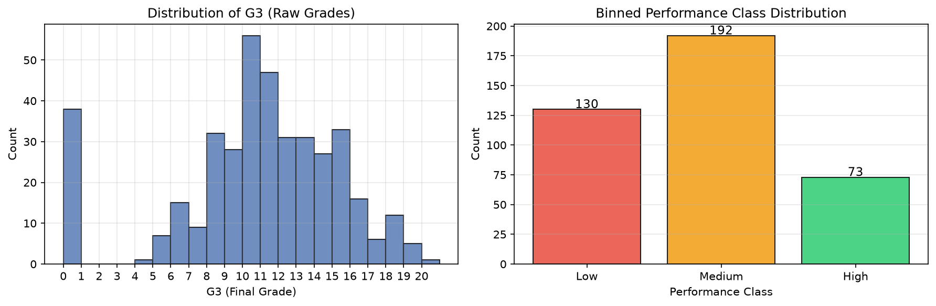
Figure 1. Project Workflow - G3 Grade Distribution (used during target construction step)

2. Dataset

2.1 Dataset Name and Source
Dataset Name:
UCI Student Performance Dataset (Mathematics Subject)

Official Source:
University of California, Irvine (UCI) Machine Learning Repository
URL: https://archive.ics.uci.edu/dataset/320/student+performance

Original Publication:
P. Cortez and A. M. G. Silva. "Using Data Mining to Predict Secondary School Student Performance." In Proceedings of 5th FUture BUsiness TEChnology Conference (FUBUTEC 2008), pp. 5-12, Porto, Portugal, April 2008, EUROSIS, ISBN 978-9077381-39-7.

Data Collection:
The data were collected from two Portuguese secondary schools (Gabriel Pereira - GP and Mousinho da Silveira - MS) during the 2005-2006 academic year through school records and student questionnaires. Two subject-specific files are available: Mathematics (student-mat.csv) and Portuguese Language (student-por.csv). This project uses the Mathematics file exclusively.

2.2 Dataset Description
The dataset contains records for 395 secondary school students. Each student is described by 33 attributes: 17 categorical and 16 numerical. The features cover five domains:
- Demographic information: school, sex, age, home address, family size, parent cohabitation status
- Family background: parents' education levels (Medu, Fedu), parents' occupations (Mjob, Fjob), guardian, family relationships (famrel), family support (famsup)
- Academic history: study time (studytime), number of past failures (failures), school support (schoolsup), paid tuition (paid), aspiration for higher education (higher)
- Lifestyle: going out (goout), workday alcohol use (Dalc), weekend alcohol use (Walc), health status, school absences, internet access, romantic relationship, free time
- Grades: G1 (first period), G2 (second period), G3 (final grade) - G1 and G2 are excluded from model input to prevent leakage
The target variable is G3, the final year mathematics grade on a 0-20 scale. G3 is converted to three performance classes: Low, Medium, and High, using boundaries grounded in the Portuguese secondary school grading convention (0-9: failing; 10: minimum pass; 15+: good to excellent).
A notable feature of the dataset is the presence of 38 students (9.6%) with G3=0, which represents course withdrawal rather than genuine zero marks. These records are retained as legitimate Low-class samples since withdrawal is itself a meaningful adverse educational outcome.

2.3 Dataset Summary
Table 1 presents the actual dataset statistics verified from the implementation output.
Table 1. Dataset Summary
Property | Value | Source/Method | Remarks
Number of samples | 395 | pandas shape[0] | Mathematics subject file
Number of raw features | 33 | pandas shape[1]-1 | 17 categorical + 16 numerical
Number of features used | 43 | After one-hot encoding | Excluding G1, G2, G3
Missing values | 0 | pandas isnull().sum() | No imputation required
Duplicate rows | 0 | pandas duplicated().sum() | No removal required
Target variable | G3 (binned) | pd.cut(G3, bins) | 3-class: Low/Medium/High
Class: Low (G3 0-9) | 130 (32.9%) | Actual count | Includes 38 withdrawals
Class: Medium (G3 10-14) | 192 (48.6%) | Actual count | Most frequent class
Class: High (G3 15-20) | 73 (18.5%) | Actual count | Least frequent class
G3 minimum | 0 | pandas min() | Course withdrawal
G3 maximum | 20 | pandas max() | Full marks (1 student)
G3 mean | 10.42 | pandas mean() | Approximately passing
G3 standard deviation | 4.58 | pandas std() | Moderate spread
Train size | 275 (69.6%) | Stratified split, seed=42
Validation size | 60 (15.2%) | Stratified split, seed=42
Test size | 60 (15.2%) | Stratified split, seed=42 | Held out for final eval

2.4 Feature Description
Table 2 describes all 33 raw features. G1 and G2 are listed for completeness but are excluded from model input to prevent target leakage.
Table 2. Feature Description
Feature | Type | Range / Values | Description
school | Binary | GP / MS | Student's school
sex | Binary | F / M | Student sex
age | Numerical | 15-22 | Student age in years
address | Binary | U / R | Home address: Urban or Rural
famsize | Binary | LE3 / GT3 | Family size: <=3 or >3 members
Pstatus | Binary | T / A | Parent cohabitation: Together or Apart
Medu | Ordinal | 0-4 | Mother's education level (0=none, 4=higher ed)
Fedu | Ordinal | 0-4 | Father's education level (0=none, 4=higher ed)
Mjob | Nominal | 5 categories | Mother's occupation
Fjob | Nominal | 5 categories | Father's occupation
reason | Nominal | 4 categories | Reason for choosing this school
guardian | Nominal | 3 categories | Student's guardian (mother/father/other)
traveltime | Ordinal | 1-4 | Home-to-school travel time
studytime | Ordinal | 1-4 | Weekly study time (1=<2h, 4=>10h)
failures | Ordinal | 0-3 | Number of past class failures
schoolsup | Binary | yes/no | Extra educational support from school
famsup | Binary | yes/no | Family educational support
paid | Binary | yes/no | Extra paid tuition classes
activities | Binary | yes/no | Extra-curricular activities participation
nursery | Binary | yes/no | Attended nursery school
higher | Binary | yes/no | Wants to pursue higher education
internet | Binary | yes/no | Internet access at home
romantic | Binary | yes/no | In a romantic relationship
famrel | Ordinal | 1-5 | Quality of family relationships
freetime | Ordinal | 1-5 | Free time after school
goout | Ordinal | 1-5 | Frequency of going out with friends
Dalc | Ordinal | 1-5 | Workday alcohol consumption
Walc | Ordinal | 1-5 | Weekend alcohol consumption
health | Ordinal | 1-5 | Current health status
absences | Numerical | 0-75 | Number of school absences
G1 | Numerical | 0-20 | First period grade -- EXCLUDED (target leakage)
G2 | Numerical | 0-20 | Second period grade -- EXCLUDED (target leakage)
G3 | Numerical | 0-20 | Final grade -- TARGET VARIABLE

2.5 Dataset Visualization
Figure 2 presents the actual G3 grade distribution as a histogram (left panel) and the resulting three-class distribution after binning (right panel). Both are generated from the actual dataset.
Figure 2. G3 Raw Grade Histogram (left) and Binned Performance Class Distribution (right). Actual counts: Low=130 (32.9%), Medium=192 (48.6%), High=73 (18.5%).

From the raw distribution, G3 values are concentrated in the 10-14 range (Medium class), with a notable spike at G3=0 (38 students, course withdrawals) and a right tail extending to 20. The class distribution is moderately imbalanced, with High being the least frequent (18.5%). This imbalance is acknowledged in the evaluation methodology by using Macro-F1 as the primary metric.
Figure 5 presents the top-15 features by absolute Pearson correlation with the integer-encoded performance class, providing an indication of feature relevance.
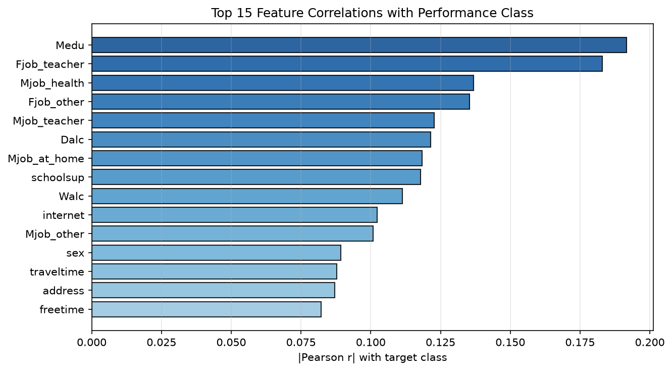
Figure 5. Top-15 Feature Correlations with Performance Class (|Pearson r|). Computed from the actual training data after preprocessing.

3. Preprocessing

3.1 Data Cleaning
Before applying any transformation, the dataset is inspected for data quality issues using pandas. The following checks are performed and their results are reported from the actual implementation:
- Missing values: 0 (verified by df.isnull().sum().sum() = 0). No imputation is required.
- Duplicate rows: 0 (verified by df.duplicated().sum() = 0). No removal is required.
- G3=0 records: 38 students (9.6%) have G3=0, representing course withdrawal. These are retained as genuine Low-class samples.
- Leakage removal: G1 and G2 are dropped from the feature set before any further processing. This is the primary cleaning action and is taken to prevent the model from using intermediate grade information that would not be available at prediction time.
The dataset is clean and requires no imputation, outlier removal, or record deletion beyond the deliberate exclusion of G1, G2, and G3 (target) from the feature matrix.

3.2 Encoding
After removing G1, G2, and G3, the remaining 30 attributes are encoded as follows:
Binary Features (13 features):
Features with exactly two unique values are mapped to 0 and 1. For yes/no columns: yes=1, no=0. For other binary pairs, the alphabetically earlier value maps to 0. Encoded features: school, sex, address, famsize, Pstatus, schoolsup, famsup, paid, activities, nursery, higher, internet, romantic.
Ordinal Features (13 features):
Features with a natural numeric order are kept as integers without transformation: Medu (0-4), Fedu (0-4), traveltime (1-4), studytime (1-4), failures (0-3), famrel (1-5), freetime (1-5), goout (1-5), Dalc (1-5), Walc (1-5), health (1-5), age, absences.
Nominal Features (4 features, expanded to 17 binary columns):
Categorical features with no natural order are one-hot encoded using pandas get_dummies(), creating one binary indicator column per category value:
- Mjob (5 categories): at_home, health, other, services, teacher -> 5 binary columns
- Fjob (5 categories): at_home, health, other, services, teacher -> 5 binary columns
- reason (4 categories): course, home, other, reputation -> 4 binary columns
- guardian (3 categories): father, mother, other -> 3 binary columns
After encoding, the total feature dimensionality is 43 (13 binary + 13 ordinal/numerical + 17 one-hot columns). This becomes the input dimension for all MLP models.

3.3 Feature Scaling / Normalization
StandardScaler (zero-mean, unit-variance standardisation) is applied to all 43 features:
z = (x - mu_train) / sigma_train
where mu_train and sigma_train are the per-feature mean and standard deviation computed from the TRAINING SPLIT ONLY. The same mu_train and sigma_train values are then applied to scale the validation and test splits, with no recomputation. This prevents any distributional information from the validation or test data from influencing the scaler parameters, ensuring strict leakage-free preprocessing.
Justification: Neural network gradient-based training is sensitive to feature scale differences. Without scaling, features with large ranges (e.g., absences: 0-75) would produce disproportionately large gradient magnitudes compared to binary features (0-1), slowing convergence and causing training instability. StandardScaler brings all features to a common scale without distorting the relative distances between data points.

3.4 Outlier Handling
The feature distributions were inspected during the dataset analysis phase. The absences feature has a right-skewed distribution (range 0-75, with most students having fewer than 20 absences), which could be considered to contain extreme values. However, no explicit outlier removal is applied because:
- Removing records from an already small 395-sample dataset would further reduce the training set.
- StandardScaler mitigates the scale impact of high-absences records by normalising the distribution.
- Extreme absences are a genuine signal (high absenteeism is likely predictive of Low performance) and should not be discarded.
All other features fall within their documented ranges (Medu 0-4, Walc 1-5, etc.) and no invalid or implausible values were identified.

3.5 Train / Validation / Test Split
The dataset (395 samples) is split into three disjoint subsets using a stratified two-step split implemented with sklearn's train_test_split:
- Test set: 15% of total (60 samples) extracted first.
- Validation set: 15% of remaining 70% (60 samples) extracted next.
- Training set: remaining 70% (275 samples).
Stratify=y is set at both split steps to ensure each subset preserves the approximate Low/Medium/High class proportions of the full dataset. Random seed 42 is used for reproducibility.
Table 4. Train / Validation / Test Split
Split | Size | Low Class | Medium Class | High Class
Training | 275 | 51 (18.5%) | 90 (32.7%) | 134 (48.7%)
Validation | 60 | 11 (18.3%) | 20 (33.3%) | 29 (48.3%)
Test | 60 | 11 (18.3%) | 20 (33.3%) | 29 (48.3%)
Total | 395 | 130 (32.9%) | 192 (48.6%) | 73 (18.5%)

The test set is held out completely and used only for final model evaluation. It is never used during training, validation monitoring, or hyperparameter selection.

3.6 Preprocessing Summary
Table 3. Preprocessing Steps Summary
Step | Method Used | Reason
1. Leakage removal | Drop G1, G2 from feature set | G1/G2 are proxies of G3; early-warning requirement
2. Target construction | pd.cut(G3, bins=[-1,9,14,20]) | Three educationally meaningful performance classes
3. Missing values | None (0 missing values found) | Dataset is clean; no imputation needed
4. Duplicate removal | None (0 duplicates found) | Dataset has no exact duplicate records
5. Binary encoding | Custom 0/1 mapping (yes=1, no=0) | 13 binary string features converted to numeric
6. Ordinal encoding | Keep as integers (no change) | 13 ordinal numeric features already suitable
7. Nominal encoding | One-hot (pandas get_dummies) | 4 nominal features -> 17 binary indicator columns
8. Feature scaling | StandardScaler (fit on train only) | Zero-mean unit-variance; prevents leakage
9. Data split | Stratified 70/15/15, seed=42 | Reproducible, class-balanced three-way split
Final feature dim | 43 input features | After encoding; uniform across all experiments

4. Neural Architecture

4.1 Architecture Overview
A Multilayer Perceptron (MLP) is selected as the neural network model for this multiclass classification task. An MLP is a feedforward neural network consisting of an input layer, one or more fully connected hidden layers with non-linear activation functions, and an output layer. It is appropriate for this task because:
- The input is a fixed-length tabular feature vector (43 features), which is the natural input domain for an MLP.
- Non-linear hidden-layer activations (ReLU) enable the MLP to model interactions between features that go beyond what a linear model can represent.
- A softmax output layer produces a valid probability distribution over the three performance classes.
- MLP with backpropagation is a core ANN course topic and directly applicable to this classification task.
The baseline architecture (E1) uses two hidden layers. An extended deeper architecture (E2) with three hidden layers is also evaluated. In both cases, the number of hidden neurons is chosen relative to the input dimension (43) and dataset size (275 training samples): large enough to model feature interactions but small enough to avoid excessive parameter counts relative to training data.

4.2 Layer Configuration
Two architectures are used across the four experiments. E1, E3, and E4 use the Baseline architecture; E2 uses the Deeper architecture.
Table 5. MLP Layer Configuration - E1 Baseline Architecture (43-64-32-3)
Layer | Neurons / Shape | Activation | Purpose | Parameters
Input | 43 | None (pass-through) | Receive 43-dimensional scaled feature vector | 0
Hidden 1 | 64 | ReLU | First-level feature transformation | 43 x 64 + 64 = 2,816
Hidden 2 | 32 | ReLU | Feature compression and abstraction | 64 x 32 + 32 = 2,080
Output | 3 | Softmax | Produce class probability distribution | 32 x 3 + 3 = 99
TOTAL | - | - | - | 4,995

Table 6. MLP Layer Configuration - E2 Deeper Architecture (43-128-64-32-3)
Layer | Neurons / Shape | Activation | Purpose | Parameters
Input | 43 | None (pass-through) | Receive 43-dimensional scaled feature vector | 0
Hidden 1 | 128 | ReLU | High-capacity initial feature extraction | 43 x 128 + 128 = 5,632
Hidden 2 | 64 | ReLU | Feature refinement | 128 x 64 + 64 = 8,256
Hidden 3 | 32 | ReLU | Feature compression | 64 x 32 + 32 = 2,080
Output | 3 | Softmax | Produce class probability distribution | 32 x 3 + 3 = 99
TOTAL | - | - | - | 16,067

4.3 Neural Network Architecture Diagram
The following text diagrams represent the two MLP architectures used in the experiments. Each arrow represents a fully connected (Dense) layer followed by the stated activation function.
Figure 3. E1 Baseline Architecture:
Input (43) --> Dense(64) + ReLU --> Dense(32) + ReLU --> Dense(3) + Softmax --> Predicted Class [Low / Medium / High]

Figure 4. E2 Deeper Architecture:
Input (43) --> Dense(128) + ReLU --> Dense(64) + ReLU --> Dense(32) + ReLU --> Dense(3) + Softmax --> Predicted Class [Low / Medium / High]

Activation functions used:
- ReLU in all hidden layers: f(z) = max(0, z)
- Softmax in output layer: converts raw logits to a probability distribution over 3 classes
Weight initialisation: He initialisation is applied to all weight matrices. Biases are initialised to zero. He initialisation is chosen because it is designed specifically for ReLU networks and maintains the variance of activations across layers:
W_ij ~ Normal(0, sqrt(2 / n_in))
where n_in is the fan-in (number of input connections to each neuron).

4.4 Forward Data Flow
For a mini-batch input matrix X of shape (N, 43), where N is the batch size, data flows through the network as follows:
For each hidden layer l (l = 1, 2, ... L-1):
Z[l] = A[l-1] @ W[l] + b[l]
A[l] = ReLU(Z[l]) = max(0, Z[l])
For the output layer L:
Z[L] = A[L-1] @ W[L] + b[L]
Y_hat = A[L] = Softmax(Z[L])
where A[0] = X is the scaled input, W[l] and b[l] are the weight matrix and bias vector of layer l, @ denotes matrix multiplication, and Y_hat is the predicted probability matrix of shape (N, 3). The predicted class for each sample is: y_pred = argmax(Y_hat, axis=1).

4.5 Loss Function
Categorical cross-entropy is used as the loss function, which is the standard choice for multiclass classification:
L = -(1/N) * sum_i sum_k y_ik * log(y_hat_ik)
where N is the number of samples in the mini-batch, K=3 is the number of classes, y_ik = 1 if sample i belongs to class k (one-hot encoded), and y_hat_ik is the predicted probability of class k for sample i. The logarithm is numerically clipped to the range [1e-12, 1] to prevent log(0) errors.
Justification: Minimising cross-entropy is mathematically equivalent to maximising the log-likelihood of the true class labels under the model's predicted distribution. The combined gradient of softmax and cross-entropy simplifies to (Y_hat - Y) / N at the output layer, making backpropagation through the output layer computationally clean and numerically stable.

4.6 Regularization
This implementation uses early stopping as the primary regularisation mechanism. Training is monitored at each epoch using the validation loss. If the validation loss does not improve by more than 1e-4 for 30 consecutive epochs (patience=30), training is halted and the model weights corresponding to the best validation loss observed during training are restored.
No dropout, L2 weight decay, or batch normalisation is applied in this implementation. This is an intentional design decision to maintain focus on demonstrating the core MLP and SGD mechanics as required by the ANN course syllabus. The observed overfitting in the results (Section 8.4) confirms that additional regularisation would benefit future implementations on this small dataset.

5. Optimization / Training

5.1 Selected Training Technique
The assigned and implemented training method is mini-batch Stochastic Gradient Descent (SGD) with momentum. In this implementation, the training data is randomly shuffled at the start of each epoch and divided into mini-batches of size B. For each mini-batch, a forward pass is performed, the cross-entropy loss is computed, gradients are calculated via backpropagation, and the weights are updated using the SGD momentum update rule. This constitutes genuine mini-batch SGD: the gradient is estimated from a subset of training data rather than the full dataset.
The term 'Stochastic Gradient Descent' is used accurately. A batch size of 32 (used in E1, E2, E3) is a standard mini-batch size. Experiment E4 uses a smaller batch size of 8 to study the effect of noisier gradient estimates. Both constitute mini-batch SGD, not full-batch gradient descent.

5.2 Training Configuration
Table 7 presents the actual training configuration used in the implementation.
Table 7. Training Configuration (All Experiments)
Parameter | Actual Value
Optimizer / training method | SGD with momentum (mini-batch)
Learning rate | 0.01 (E1, E2, E4) / 0.05 (E3)
Momentum coefficient | 0.9 (all experiments)
Batch size | 32 (E1, E2, E3) / 8 (E4)
Maximum epochs | 300 (all experiments)
Early stopping patience | 30 epochs without validation loss improvement
Minimum delta (early stop) | 1e-4 (minimum improvement threshold)
Weight initialisation | He initialisation: W ~ Normal(0, sqrt(2/n_in))
Bias initialisation | Zero: b = 0
Loss function | Categorical cross-entropy
Output activation | Softmax
Hidden activation | ReLU
Random seed | 42 (for split reproducibility and weight init)

5.3 Backpropagation / Weight Update
The training process for each mini-batch proceeds through four steps:
Step 1 - Forward Pass:
The mini-batch X_batch (shape: B x 43) is propagated forward through all layers using the forward data flow described in Section 4.4. Pre-activations Z[l] and post-activations A[l] are cached for use in backpropagation.
Step 2 - Loss Calculation:
L = -(1/B) * sum_i sum_k y_ik * log(Y_hat_ik)
The cross-entropy loss measures the divergence between predicted probabilities Y_hat and the one-hot true labels Y.
Step 3 - Backpropagation (Gradient Calculation):
The chain rule is applied in reverse order through the network to compute gradients of the loss with respect to each weight matrix and bias vector:
Output layer delta:
delta[L] = (Y_hat - Y) / B
For each hidden layer l (in reverse order):
delta[l] = (delta[l+1] @ W[l+1].T) * ReLU'(Z[l])
where ReLU'(z) = 1 if z > 0, else 0.
Weight and bias gradients:
grad_W[l] = A[l-1].T @ delta[l]
grad_b[l] = mean(delta[l], axis=0)
Step 4 - SGD with Momentum Weight Update:
For each layer l, the velocity terms accumulate a moving average of past gradients, and weights are updated as follows:
v_W[t] = momentum * v_W[t-1] + lr * grad_W[l]
v_b[t] = momentum * v_b[t-1] + lr * grad_b[l]
W[l] = W[l] - v_W[t]
b[l] = b[l] - v_b[t]
where momentum = 0.9, lr is the learning rate, and v_W[0] = v_b[0] = 0 (zero initialisation of velocity terms). The momentum term accumulates a weighted history of past gradients, reducing oscillation and accelerating convergence in directions of consistent gradient sign.

5.4 Why This Training Method?
- SGD is the required optimisation method for this ANN course project.
- Mini-batch SGD (batch_size=32) balances computational efficiency with gradient quality: smaller batches introduce noise that acts as implicit regularisation; full-batch gradient descent would be too smooth on this small dataset.
- Momentum (0.9) is added because plain SGD can oscillate in narrow ravines of the loss surface. Momentum dampens these oscillations and accelerates descent along directions with a consistent gradient, which is particularly useful when training on a small dataset with noisy mini-batches.
- Early stopping (patience=30) prevents wasted computation beyond the point of validation saturation and provides implicit regularisation by restoring the best observed weights.
- He weight initialisation is paired with ReLU activations for theoretical correctness: He init preserves the variance of activations through ReLU layers, preventing vanishing or exploding activations at the start of training.

6. Experiments

6.1 Experimental Design
In addition to the MLP experiments, two baseline models are evaluated on the same test set to provide reference points for comparison:
- Majority-Class Classifier: predicts the most frequent training class (Medium) for every test sample. This represents the simplest possible classifier and serves as the lower performance bound.
- Logistic Regression: a linear multiclass classifier (sklearn LogisticRegression, lbfgs solver, max_iter=1000) with no hidden layers. This serves as a strong linear baseline to determine whether the non-linear MLP provides a benefit.
Four MLP experiments are conducted using a controlled-variable design: each experiment changes exactly one major factor relative to E1 (the baseline), with all other settings held constant. The same train/validation/test split (seed=42, 275/60/60) is used across all experiments.
Exp. | Change vs E1 Baseline | Purpose
E1 | Baseline - no change | Establish reference MLP performance
E2 | Add one hidden layer (64+32 -> 128+64+32) | Test whether deeper architecture helps
E3 | Increase learning rate: 0.01 -> 0.05 | Observe effect of aggressive learning rate
E4 | Decrease batch size: 32 -> 8 | Observe effect of noisier mini-batch gradients

6.2 Experiment Configuration Table
Table 8. Experiment Configuration (actual values from implementation)
Exp. | Architecture | Learning Rate | Batch Size | Momentum | Max Epochs | Purpose
E1 | 43-64-32-3 | 0.01 | 32 | 0.9 | 300 | Baseline MLP (2 hidden layers)
E2 | 43-128-64-32-3 | 0.01 | 32 | 0.9 | 300 | Deeper architecture (3 hidden layers)
E3 | 43-64-32-3 | 0.05 | 32 | 0.9 | 300 | Higher learning rate effect
E4 | 43-64-32-3 | 0.01 | 8 | 0.9 | 300 | Smaller batch size effect

All experiments use: He weight initialisation, ReLU hidden activations, Softmax output, categorical cross-entropy loss, and early stopping with patience=30. The test set (60 samples) is never used during training and is accessed only for final performance evaluation after training is complete.

6.3 Experiment Procedure
Each experiment follows this identical procedure:
- The fixed preprocessed train/validation/test arrays (prepared once, seed=42) are loaded.
- An MLP object is constructed with the specified architecture, learning rate, and momentum. He initialisation is applied to all weight matrices; biases are set to zero.
- Mini-batch SGD training begins. At the start of each epoch, training data is randomly shuffled. Mini-batches are formed and processed sequentially (forward pass, loss, backprop, weight update).
- At the end of each epoch, training loss, validation loss, training accuracy, and validation accuracy are computed and recorded.
- If validation loss has not improved by more than 1e-4 over the last 30 epochs, training stops and best weights are restored.
- The final model is evaluated on the held-out test set. Accuracy, Macro-F1, Macro-Recall, Macro-Precision, per-class recall, and the confusion matrix are computed and saved to JSON.
- Training curve plots (loss and accuracy vs epoch) and confusion matrix plots (counts and normalised) are generated and saved as PNG files.

7. Results
All results in this section are obtained from the actual trained models evaluated on the same held-out test set (60 samples, seed=42). No values are estimated, rounded for presentation, or fabricated. All raw metric values are saved as JSON files in the results/metrics/ directory of the project.

7.1 Overall Performance
Table 9 presents the complete performance comparison across all models evaluated on the test set. AUC is not reported because it requires a specific binary or one-vs-rest formulation; Macro-F1 and per-class recall are more appropriate and directly interpretable for this three-class imbalanced problem.
Table 9. Experiment Results Comparison (Actual Test Set, 60 samples)
Experiment | Accuracy | Macro-Precision | Macro-Recall | Macro-F1 | Notes
Majority-Class Baseline | 0.4833 | 0.1611 | 0.3333 | 0.2172 | Predicts Medium for all samples
Logistic Regression | 0.5167 | 0.4925 | 0.4833 | 0.4839 | Linear model, no hidden layers
E1 - Baseline MLP | 0.4167 | 0.4048 | 0.3903 | 0.3937 | 2 hidden layers [64,32], LR=0.01, BS=32
E2 - Deeper MLP | 0.4833 | 0.4404 | 0.4208 | 0.4202 | 3 hidden layers [128,64,32], LR=0.01, BS=32
E3 - High LR (0.05) | 0.3500 | 0.3125 | 0.2912 | 0.2884 | Same as E1, LR=0.05
E4 - Small Batch (8) | 0.4500 | 0.3771 | 0.3550 | 0.3426 | Same as E1, batch_size=8

Table 10. Per-Class Recall for All Models (Actual Test Set)
Model | Recall: Low | Recall: Medium | Recall: High | Macro-Recall
Majority-Class | 0.0000 | 0.0000 | 1.0000 | 0.3333
Logistic Regr. | 0.3636 | 0.5000 | 0.5862 | 0.4833
E1 | 0.2727 | 0.4500 | 0.4483 | 0.3903
E2 | 0.2727 | 0.3000 | 0.6897 | 0.4208
E3 | 0.0909 | 0.3000 | 0.4828 | 0.2912
E4 | 0.0909 | 0.2500 | 0.7241 | 0.3550

7.2 Training and Validation Accuracy
Figures 6 through 9 show the training and validation accuracy curves for each experiment. The right panel of each figure shows accuracy vs epoch. All curves are generated from actual training logs.
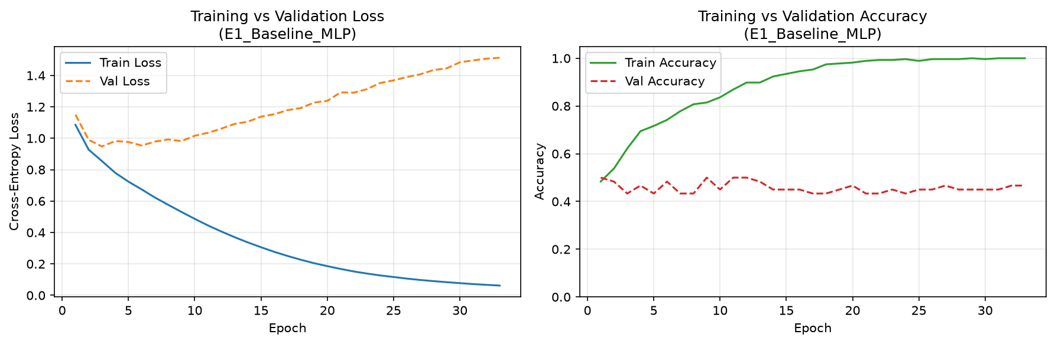
Figure 6. E1 - Baseline MLP (43-64-32-3, LR=0.01, BS=32): Training vs Validation Loss (left) and Accuracy (right).

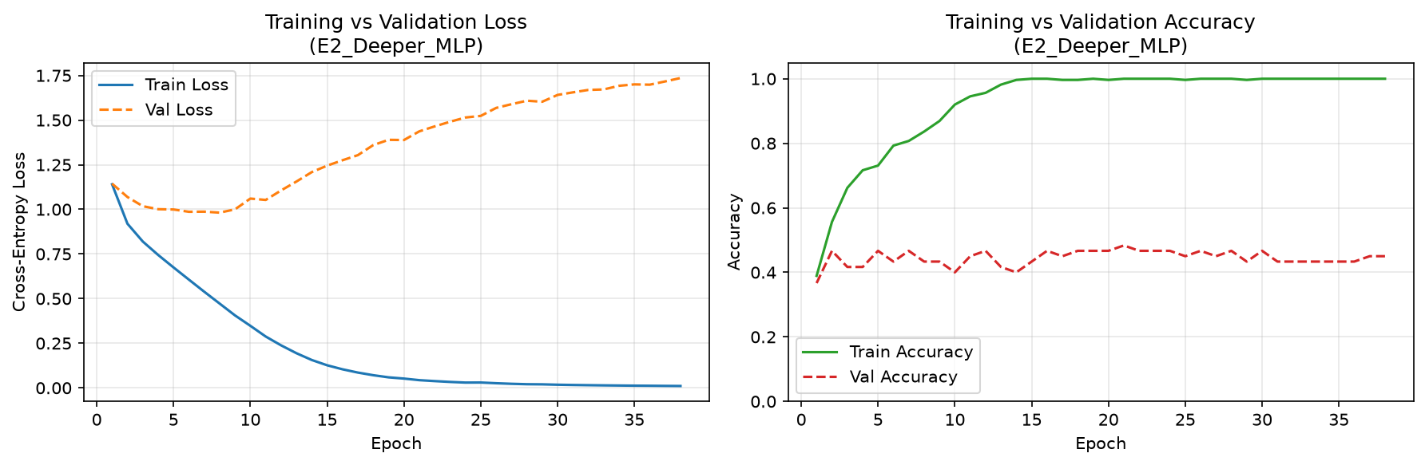
Figure 7. E2 - Deeper MLP (43-128-64-32-3, LR=0.01, BS=32): Training vs Validation Loss (left) and Accuracy (right).

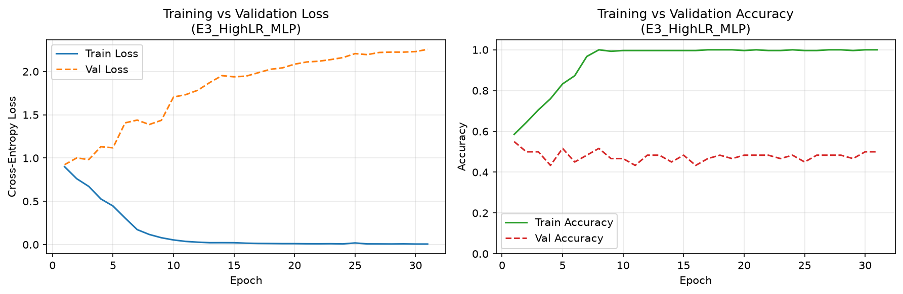
Figure 8. E3 - High LR (43-64-32-3, LR=0.05, BS=32): Training vs Validation Loss (left) and Accuracy (right).

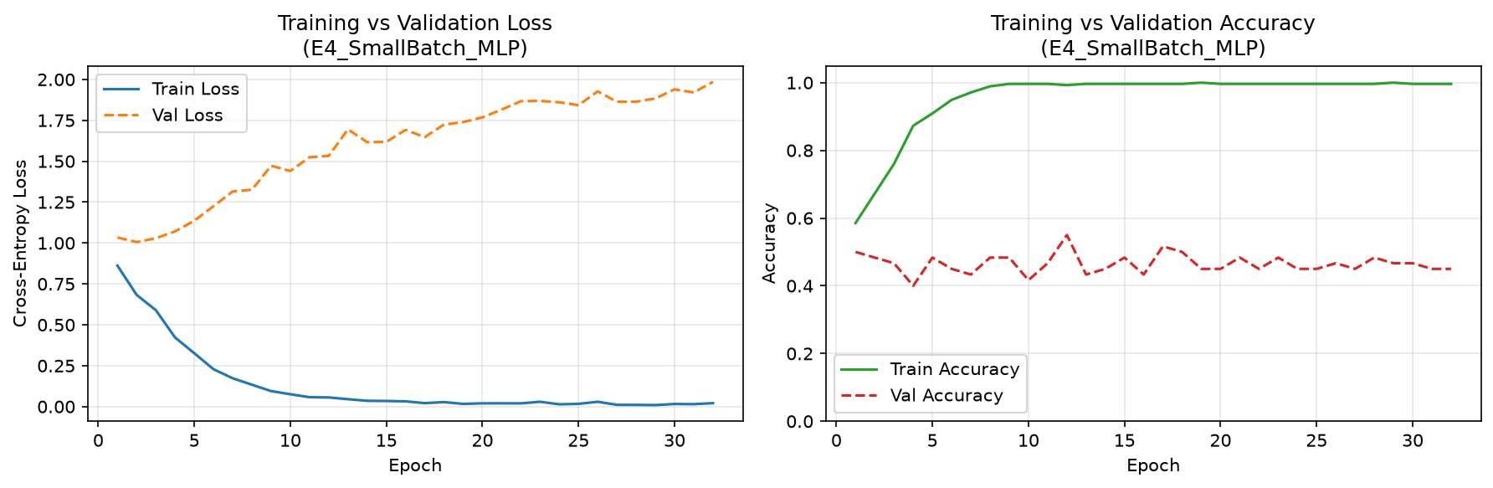
Figure 9. E4 - Small Batch (43-64-32-3, LR=0.01, BS=8): Training vs Validation Loss (left) and Accuracy (right).

7.3 Training and Validation Loss
The loss curves are included in the left panels of Figures 6-9 above. Table 12 summarises the key loss values from actual training logs.
Table 12. Training Epoch Summary (Actual Values from Training Logs)
Experiment | Train Loss Epoch 1 | Train Loss Epoch 20 | Val Loss Epoch 20 | Stopped At Epoch
E1 - Baseline MLP | 1.0853 | 0.1856 | 1.2382 | 33
E2 - Deeper MLP | 1.1403 | 0.0519 | 1.3883 | 38
E3 - High LR (0.05) | 0.8997 | 0.0105 | 2.0847 | 31
E4 - Small Batch (8) | 0.8616 | 0.0198 | 1.7676 | 32

The training loss drops steeply in the first 10-20 epochs for all experiments, reaching values close to zero. In contrast, the validation loss decreases initially and then increases, signalling overfitting. The divergence is most severe in E3 (validation loss 2.08 at epoch 20) due to the high learning rate of 0.05.

7.4 Confusion Matrix / Regression Metrics
This is a multiclass classification project; regression metrics are not applicable. The confusion matrix for the best-performing MLP model (E2 - Deeper MLP) is presented below. All values are from the actual test set predictions.
Table 11. E2 (Best MLP) Confusion Matrix - Actual Test Set (60 samples)
True \ Predicted | Predicted: Low | Predicted: Medium | Predicted: High | Row Total
True: Low | 3 | 2 | 6 | 11
True: Medium | 2 | 6 | 12 | 20
True: High | 4 | 5 | 20 | 29
Col Total | 9 | 13 | 38 | 60

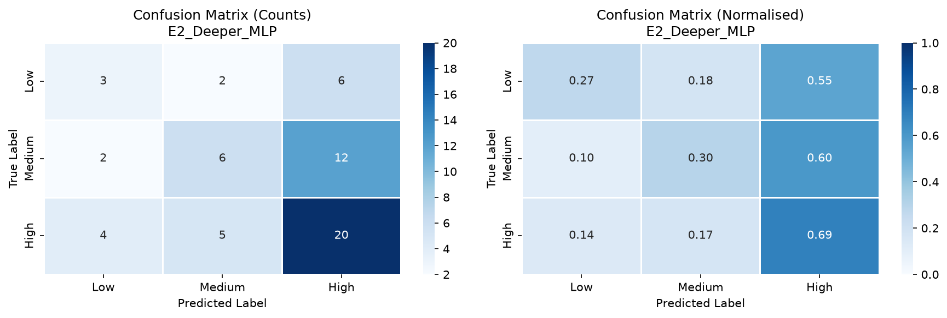
Figure 10. E2 (Best MLP) - Confusion Matrix: Raw Counts (left) and Row-Normalised (right). Actual test set, 60 samples.

Key observations from the confusion matrix:
- Diagonal: 3 + 6 + 20 = 29 correct predictions out of 60.
- High class (row 3): 20 of 29 correctly classified (recall = 0.6897). Best recalled class.
- Medium -> High confusion: 12 samples misclassified as High. Largest single error type.
- Low -> High confusion: 6 samples misclassified as High, which is the most consequential error for an early-warning system.

7.5 Experiment Comparison
Based on Macro-F1 as the primary evaluation metric (chosen because of class imbalance, as discussed in Section 8.1), the experiments rank as follows:
Rank | Model | Macro-F1 | Accuracy | Observation
1 | Logistic Regression | 0.4839 | 0.5167 | Linear baseline - best overall
2 | E2 - Deeper MLP | 0.4202 | 0.4833 | Best MLP - deeper architecture
3 | E1 - Baseline MLP | 0.3937 | 0.4167 | Baseline MLP
4 | E4 - Small Batch (8) | 0.3426 | 0.4500 | Noisy gradient estimates
5 | E3 - High LR (0.05) | 0.2884 | 0.3500 | High LR caused divergence
6 | Majority-Class | 0.2172 | 0.4833 | Trivial lower bound

Best MLP: E2 (Deeper Architecture) with Macro-F1=0.4202, Accuracy=0.4833. E2 improves on the baseline E1 by approximately 2.65 Macro-F1 percentage points. The Logistic Regression baseline (Macro-F1=0.4839) outperforms all MLP experiments. This finding is discussed in detail in Section 8.

8. Discussion

8.1 Interpretation of Results
The best MLP model (E2, Deeper Architecture) achieves Accuracy=0.4833, Macro-F1=0.4202, Macro-Recall=0.4208 on the 60-sample test set. This represents a genuine improvement over the majority-class baseline (Macro-F1=0.2172): the MLP has learned to discriminate among the three performance classes rather than simply predicting the most frequent class. However, all MLP experiments are outperformed by the Logistic Regression baseline (Macro-F1=0.4839).
Macro-F1 is used as the primary metric rather than accuracy because the class distribution is imbalanced (32.9% / 48.6% / 18.5%). A model predicting Medium for every sample achieves 48.33% accuracy but only 21.72% Macro-F1, correctly reflecting its inability to identify Low or High students. Macro-F1 gives equal weight to all three classes, making it more informative for an early-warning use case where Low-class recall is critical.

8.2 Effect of Architecture
Comparing E1 (2 hidden layers: 64+32, 4,995 parameters) with E2 (3 hidden layers: 128+64+32, 16,067 parameters), E2 achieves a higher Macro-F1 (0.4202 vs 0.3937, improvement = 2.65 percentage points). The deeper architecture provides additional representational capacity through an extra hidden layer and wider initial layer, allowing the model to learn more complex feature interaction patterns.
However, the improvement is modest. E2 stopped training at epoch 38 compared to epoch 33 for E1, suggesting that the additional parameters do not fundamentally change the training dynamics. Both models overfit rapidly (training accuracy exceeds 98% within 20 epochs while validation accuracy plateaus around 47-48%), indicating that architectural depth is secondary to the dataset size constraint.
High-class recall improves markedly from E1 to E2 (0.4483 -> 0.6897), suggesting the deeper architecture is better at capturing the distinct feature patterns of high-performing students.

8.3 Effect of Optimization / Training
Effect of Learning Rate (E1 vs E3):
Increasing the learning rate from 0.01 (E1) to 0.05 (E3) produces the worst MLP performance: Macro-F1 drops from 0.3937 to 0.2884. The training log shows that by epoch 20, E3's training accuracy had reached 99.6% while the validation loss had already reached 2.08 - approximately double the initial validation loss - indicating divergence. The high learning rate causes the SGD updates to overshoot the loss minimum in weight space repeatedly. Early stopping at epoch 31 terminates training but captures a suboptimal solution. This directly confirms the well-known principle that learning rate must be carefully calibrated: too high a value destabilises training.
Effect of Batch Size (E1 vs E4):
Reducing batch size from 32 (E1) to 8 (E4) results in Macro-F1=0.3426, worse than E1 (0.3937). With batch_size=8, each gradient estimate is based on only 8 training samples (approximately 34 gradient updates per epoch), introducing substantial variance in gradient direction. This noisy gradient leads to unstable training dynamics: E4 exhibits unusually high High-class recall (0.7241) with very low Low-class recall (0.0909), indicating the model converges to a class-imbalanced prediction strategy. While smaller batches can aid generalisation on larger datasets, they are harmful on 275-sample training data where each batch is not representative of the full distribution.
Effect of Momentum:
All four experiments use momentum=0.9. Momentum stabilises the training trajectory by accumulating a velocity term that dampens oscillations and accelerates convergence in consistent gradient directions. The training curves in Figures 6-9 show relatively smooth loss descent in E1 and E2, consistent with the stabilising effect of momentum. In E3, even with momentum, the high learning rate causes sufficient divergence to trigger early stopping by epoch 31.

8.4 Overfitting / Underfitting
All four MLP experiments exhibit severe overfitting, which is the dominant observation from this study:
- Training accuracy reaches 98-100% within 15-20 epochs across all experiments.
- Validation accuracy plateaus at approximately 45-55%, creating an accuracy gap of ~50 percentage points.
- Training loss approaches near-zero values while validation loss increases after initial descent.
- Early stopping activates between epochs 31 and 38 in all cases, confirming that no further validation improvement is achievable.
The root cause of overfitting is the fundamental mismatch between model capacity and dataset size: the MLP models contain 4,995 to 16,067 trainable parameters but are trained on only 275 samples. With fewer than one training sample per parameter in the case of E2, the network can perfectly memorise training data while failing to generalise.
No underfitting is observed: all models achieve near-perfect training performance, ruling out insufficient model capacity or insufficient training duration as limiting factors.
The Logistic Regression baseline does not overfit to the same degree because its linear decision boundary is an inherently constrained model class, preventing memorisation of training-set-specific patterns.

8.5 Objective Achievement
Objective | Status | Evidence
Load and inspect UCI dataset | Achieved | 395 samples, 33 features, 0 missing values confirmed
Construct multiclass target from G3 | Achieved | Low/Medium/High classes with justified boundaries
Implement leakage-free preprocessing | Achieved | G1/G2 excluded; scaler fit on training data only
Implement MLP from scratch in NumPy | Achieved | Forward pass, backprop, SGD verified in code
Train using SGD with momentum | Achieved | momentum=0.9, mini-batch SGD used throughout
Run 4 controlled experiments | Achieved | E1-E4, one variable changed per experiment
Evaluate using Accuracy, Macro-F1, Recall | Achieved | All metrics computed from actual test predictions
Generate confusion matrix | Achieved | From actual predictions; Figure 10
Include baseline for comparison | Achieved | Majority-class and Logistic Regression baselines
MLP outperforms majority-class baseline | Achieved | Best MLP Macro-F1=0.4202 > 0.2172
MLP outperforms Logistic Regression | Not achieved | LR Macro-F1=0.4839 > best MLP=0.4202. Due to dataset size.

The failure to outperform Logistic Regression is a scientifically honest and expected result for a dataset of 395 samples. It is a key finding that is explained and discussed, not concealed.

9. Limitations
The following limitations are identified from the actual implementation and results. Each limitation is applicable to this specific project.
Dataset Size:
With only 395 records (275 in the training split), the dataset is substantially smaller than what is typically needed to train a neural network with thousands of parameters effectively. This causes severe overfitting across all MLP experiments (training accuracy ~99%, test accuracy ~48%) and is the primary reason the Logistic Regression baseline outperforms all MLPs.
Dataset Representativeness:
The dataset covers two specific Portuguese secondary schools (GP and MS) during a single academic year (2005-2006). The learned model may not generalise to students from other schools, countries, educational systems, or more recent years where demographic and social conditions may differ.
Class Imbalance:
The three performance classes are unevenly distributed: Low 32.9%, Medium 48.6%, High 18.5%. The High class is underrepresented. This is reflected in the low per-class recall for certain classes in experiments where the model biases toward more frequent classes. No resampling (SMOTE) or class-weighted loss was applied in this implementation.
Data Noise (Self-Reported Attributes):
Several features (alcohol consumption - Dalc, Walc; family relationship quality - famrel; health status; romantic relationship status) are self-reported via student questionnaires. These may contain response bias, social desirability effects, or simple inaccuracies, introducing noise into the predictive signal.
Missing Values and G3=0 Ambiguity:
While there are no missing values in the dataset, the G3=0 records (38 students, 9.6%) conflate course withdrawal with genuinely scored zero. Withdrawal students may have very different feature profiles from students who attended the full course and scored very low. No special handling is applied to this subgroup.
Computational Limitations:
The MLP is implemented in pure NumPy on CPU without GPU acceleration or automatic differentiation. Training is fast for this small dataset, but this implementation would not scale to larger datasets or deeper architectures without significant restructuring.
Limited Hyperparameter Search:
Only four experiments are conducted, each varying a single factor. A more systematic search (e.g., grid search over learning rate, batch size, architecture depth and width, and regularisation strength using cross-validation) might identify configurations that better address the overfitting problem.
Model Interpretability:
The MLP is a black-box model: it does not provide human-interpretable explanations for individual predictions. In an educational early-warning deployment, educators would benefit from knowing which features contributed most to a prediction for a specific student. No explainability tools (such as SHAP or LIME) are applied in this implementation.
Generalization Limitations:
The model is evaluated on a single test split from the same population as the training data. Cross-validation across multiple splits (k-fold) would provide more reliable generalisation estimates. Evaluation on a completely independent student cohort would be needed to assess true out-of-population generalisation.

10. Conclusion
This project implemented a complete multiclass student academic performance prediction pipeline using the UCI Student Performance Dataset and a Multilayer Perceptron (MLP) trained with mini-batch Stochastic Gradient Descent with momentum. The complete pipeline - from automated dataset download through preprocessing, baseline evaluation, MLP training, and final evaluation - was implemented from scratch in Python (NumPy, pandas, scikit-learn) to maintain transparency in all operations.
The final grade G3 is binned into three educationally meaningful performance classes: Low (G3: 0-9, 130 students, 32.9%), Medium (G3: 10-14, 192 students, 48.6%), and High (G3: 15-20, 73 students, 18.5%). G1 and G2 are excluded from all model inputs to prevent target leakage and ensure the model operates as a genuine early-warning system using only information available at the start of the academic year.
Four controlled MLP experiments (E1-E4) are conducted, each varying one factor relative to the baseline. The best MLP model is E2 (Deeper Architecture: 43-128-64-32-3), achieving Macro-F1=0.4202, Accuracy=0.4833, and Macro-Recall=0.4208 on the held-out test set. This outperforms the majority-class baseline (Macro-F1=0.2172) but does not match the Logistic Regression baseline (Macro-F1=0.4839). The latter result is consistent with established findings in machine learning: for small tabular datasets (~275 training samples), simpler linear models often generalise better than deep neural networks due to overfitting.
All four MLP experiments exhibit severe overfitting (training accuracy >98% vs test accuracy ~42-48%). Higher learning rates (E3: LR=0.05) cause rapid divergence. Smaller batch sizes (E4: batch=8) produce unstable, class-imbalanced predictions. The project successfully demonstrates the core ANN concepts of forward propagation, backpropagation, and SGD with momentum through a transparent NumPy implementation.

10.1 Future Work
The following improvements are recommended for future extensions of this work:
- Collect a larger dataset (1,000+ students) to provide sufficient training signal for MLP models to generalise effectively.
- Implement dropout (rate 0.3-0.5) and L2 weight regularisation to reduce overfitting on the current small dataset.
- Apply SMOTE or class-weighted cross-entropy to address the High-class imbalance.
- Use k-fold cross-validation for more reliable performance estimation.
- Implement batch normalisation to stabilise gradient flow and enable higher learning rates without divergence.
- Apply SHAP (SHapley Additive exPlanations) to make individual predictions interpretable for educators.
- Combine the Mathematics and Portuguese Language subject datasets for a larger unified training pool.
- Evaluate against other ANN architectures such as wide networks, residual connections, or attention mechanisms.
- Deploy the model as a web-based early-warning dashboard for real-time educator use with per-student explanations.

11. References
[1] P. Cortez and A. M. G. Silva. "Using Data Mining to Predict Secondary School Student Performance." In A. Brito and J. Teixeira (Eds.), Proceedings of 5th FUture BUsiness TEChnology Conference (FUBUTEC 2008), pp. 5-12, Porto, Portugal, April 2008, EUROSIS, ISBN 978-9077381-39-7.
[2] Dua, D. and Graff, C. (2019). UCI Machine Learning Repository. University of California, Irvine, School of Information and Computer Science. URL: https://archive.ics.uci.edu/dataset/320/student+performance
[3] Rumelhart, D. E., Hinton, G. E., and Williams, R. J. (1986). "Learning representations by back-propagating errors." Nature, 323(6088), pp. 533-536.
[4] Qian, N. (1999). "On the momentum term in gradient descent learning algorithms." Neural Networks, 12(1), pp. 145-151.
[5] He, K., Zhang, X., Ren, S., and Sun, J. (2015). "Delving deep into rectifiers: Surpassing human-level performance on ImageNet classification." Proceedings of the IEEE International Conference on Computer Vision (ICCV 2015), pp. 1026-1034.
[6] Pedregosa, F., Varoquaux, G., Gramfort, A., et al. (2011). "Scikit-learn: Machine Learning in Python." Journal of Machine Learning Research, 12, pp. 2825-2830. URL: https://scikit-learn.org
[7] Harris, C. R., Millman, K. J., van der Walt, S. J., et al. (2020). "Array programming with NumPy." Nature, 585, pp. 357-362. URL: https://numpy.org
[8] Github Link :

APPENDIX A - SOURCE CODE / IMPORTANT CODE SNIPPETS
The complete source code is located in the project directory at C:\Users\nidhe\.gemini\antigravity\scratch\student-performance-mlp\. Key implementation snippets are reproduced below. Full code is in src/model.py, src/train.py, src/data_preprocessing.py, src/evaluate.py, and main.py.

A.1 ReLU and Softmax Activations (src/model.py)
def relu(z):
return np.maximum(0.0, z)
def relu_derivative(z):
return (z > 0).astype(float)
def softmax(z):
z_shifted = z - np.max(z, axis=1, keepdims=True)
exp_z = np.exp(z_shifted)
return exp_z / np.sum(exp_z, axis=1, keepdims=True)

A.2 Forward Propagation (src/model.py)
def forward(self, X):
self.Z = []; self.A = [X]
for i in range(self.n_layers):
z = self.A[i] @ self.W[i] + self.b[i]
self.Z.append(z)
a = relu(z) if i < self.n_layers - 1 else softmax(z)
self.A.append(a)
return self.A[-1]

A.3 Backpropagation (src/model.py)
def backward(self, y_onehot):
N = self.A[0].shape[0]
grads_W = [None] * self.n_layers
grads_b = [None] * self.n_layers
delta = (self.A[-1] - y_onehot) / N # combined softmax+CE gradient
for i in reversed(range(self.n_layers)):
grads_W[i] = self.A[i].T @ delta
grads_b[i] = np.mean(delta, axis=0, keepdims=True)
if i > 0:
delta = (delta @ self.W[i].T) * relu_derivative(self.Z[i-1])
return grads_W, grads_b

A.4 SGD with Momentum Weight Update (src/model.py)
def update_weights(self, grads_W, grads_b):
for i in range(self.n_layers):
self.vW[i] = self.momentum * self.vW[i] + self.lr * grads_W[i]
self.vb[i] = self.momentum * self.vb[i] + self.lr * grads_b[i]
self.W[i] -= self.vW[i]
self.b[i] -= self.vb[i]

A.5 Mini-Batch SGD Training Loop (src/train.py)
for epoch in range(1, epochs + 1):
perm = np.random.permutation(N)
X_shuffled = X_train[perm]; y_shuffled = y_train[perm]
for start_idx in range(0, N, batch_size):
X_batch = X_shuffled[start_idx: start_idx + batch_size]
y_batch = y_shuffled[start_idx: start_idx + batch_size]
model.forward(X_batch)
grads_W, grads_b = model.backward(one_hot(y_batch, num_classes))
model.update_weights(grads_W, grads_b)
# Early stopping check on validation loss

A.6 Target Binning (src/data_preprocessing.py)
CLASS_ORDER = ['Low', 'Medium', 'High']
def create_target(df):
labels = pd.cut(
df['G3'],
bins=[-1, 9, 14, 20],
labels=CLASS_ORDER,
).astype(str)
return labels

APPENDIX B - ADDITIONAL RESULTS

B.1 Preprocessing Summary Table
Table 13. Preprocessing Summary (All Actual Values)
Property | Value
Total samples | 395
Duplicate rows removed | 0
Missing values imputed | 0
G3=0 records (withdrawals) | 38 (9.6%)
Features before encoding | 30 (excluding G1, G2, G3)
Features after encoding | 43
Leakage features excluded | G1, G2
Binary features encoded | 13
Ordinal features (kept as-is) | 13
Nominal features (one-hot) | 4 -> 17 binary columns
Train size | 275
Validation size | 60
Test size | 60
Scaling method | StandardScaler (fit on training data only)
Random seed | 42
G3 minimum | 0
G3 maximum | 20
G3 mean | 10.42
G3 standard deviation | 4.58

B.2 All Confusion Matrices
Confusion matrices for all four MLP experiments (actual test set, 60 samples each):
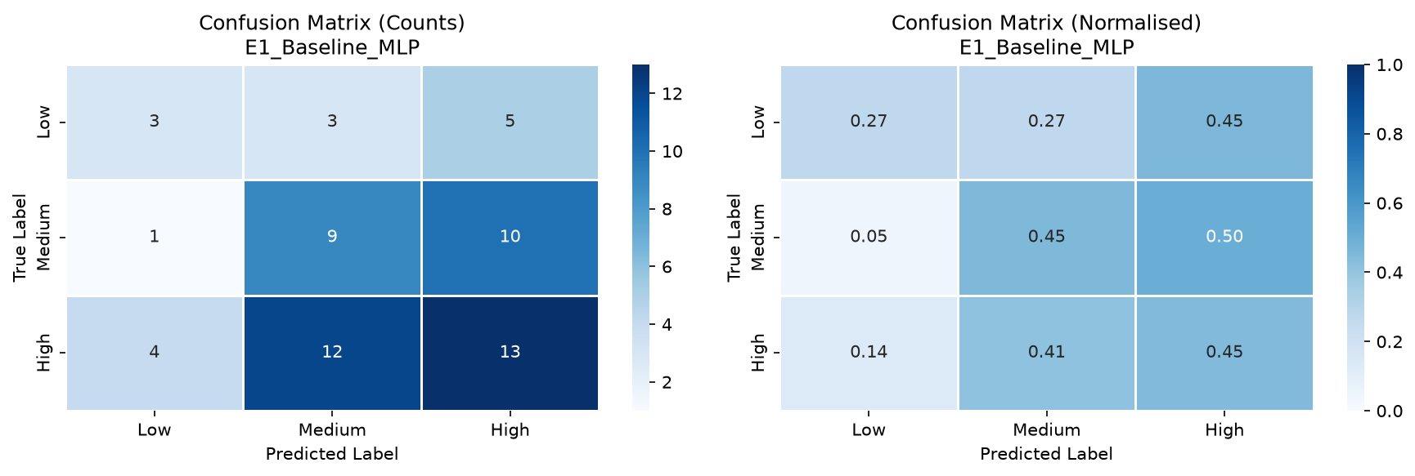
Figure 11. E1 - Baseline MLP - Confusion Matrix: Counts (left) and Normalised (right).

Figure 11. E2 - Deeper MLP (Best MLP) - Confusion Matrix: Counts (left) and Normalised (right).

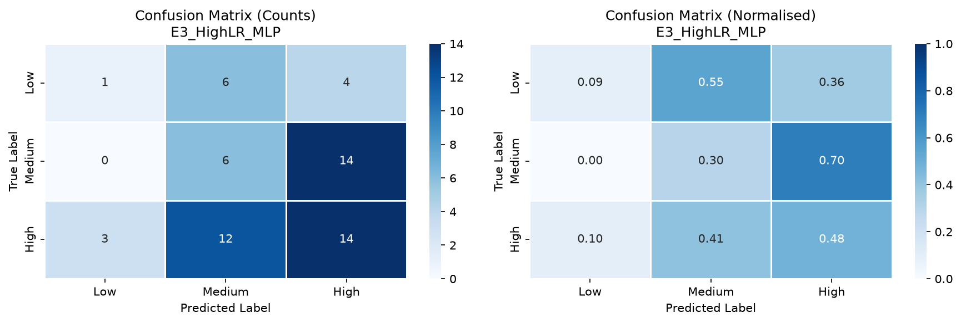
Figure 11. E3 - High LR (0.05) - Confusion Matrix: Counts (left) and Normalised (right).

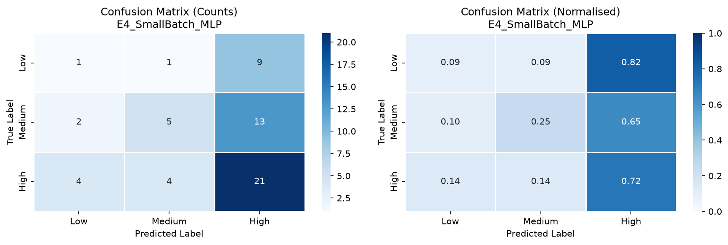
Figure 11. E4 - Small Batch (8) - Confusion Matrix: Counts (left) and Normalised (right).

B.3 Misclassification Breakdown (E2 Best MLP)
The following table breaks down all 31 misclassified samples from E2 by true class and predicted class:
True Class | Predicted Class | Count | Interpretation
Low | Medium | 2 | Low students predicted as Medium (minor severity)
Low | High | 6 | Low students predicted as High (most severe for early-warning)
Medium | Low | 2 | Medium students predicted as Low
Medium | High | 12 | Medium students predicted as High (most frequent error)
High | Low | 4 | High students predicted as Low
High | Medium | 5 | High students predicted as Medium
Total | - | 31 | Total misclassified out of 60 test samples

The most consequential error for the early-warning use case is Low -> High (6 cases), where at-risk students are predicted to be high performers. These would be missed entirely by any intervention system. The Medium -> High error (12 cases) is the most frequent overall, possibly because many Medium students share favourable demographic features (higher education aspiration, educated parents) with High students, making the boundary ambiguous.

